**Organizing Test Cases and Folders**

**In the test plan module, folder names can be unrelated to the test cases**

**To get the best visual and logical use out of the folders**

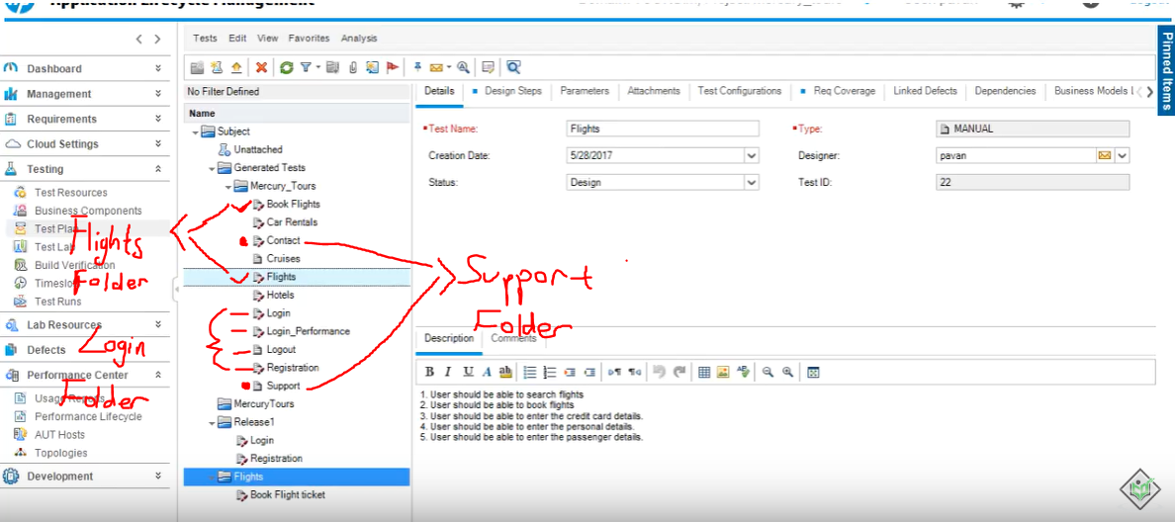

**We can organize the related test cases and put it under a Folder that logically makes sense**

**We can do this by simply dragging and dropping the test cases under that new folder**

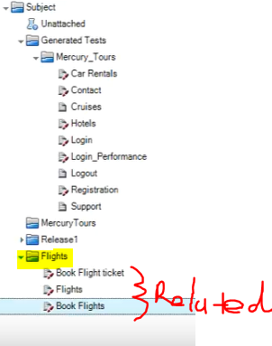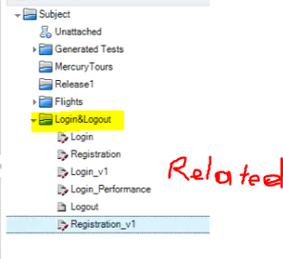

**Then we can delete the empty folders**

